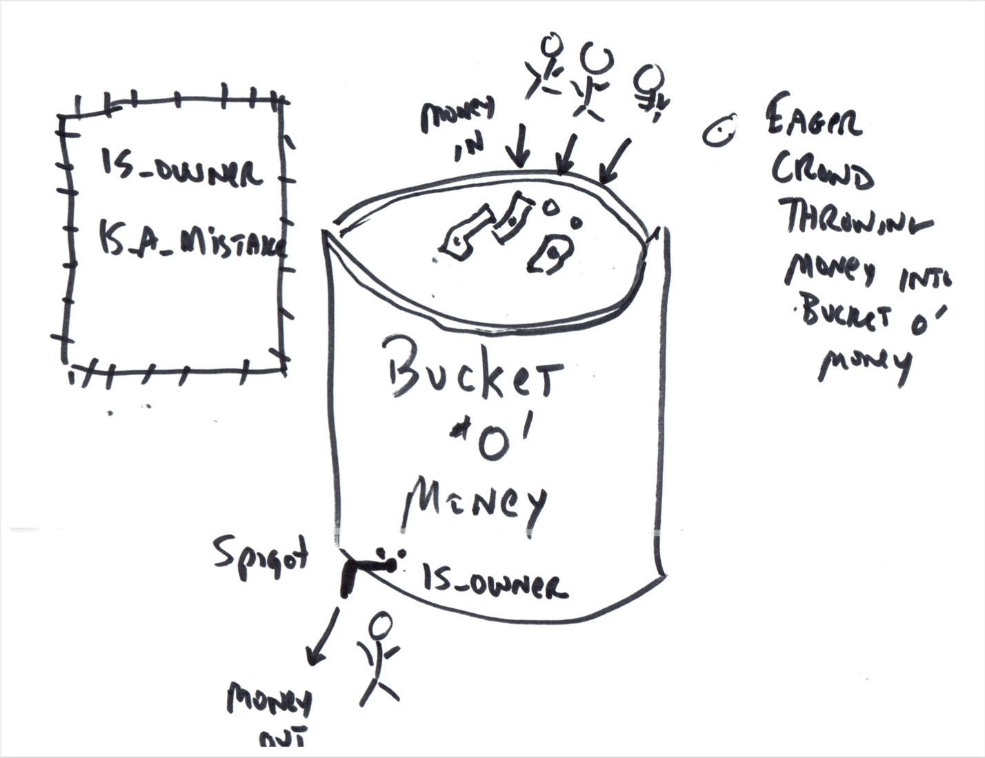

This image plays off of the 2017 ICO craze where people were writing smart contracts that would sell ERC 20 tokens in return for Ethereum. I see those ICO contracts as “buckets o’ money” where a great rabble of people were lining up for the chance to shove their ETH in at the top of the bucket while at the bottom of the bucket was a spigot where the owner of the contract could simply remove the ETH in return for the tokens.

The people at the top are ravenously shoving their ETH (their money) into the bucket. Fighting to get in. The people at the bottom or taking the ETH out as quickly as it comes in.

Next to the spigot is a sign (perhaps something like the FUCKED up “Whites Only” signs in America’s deep south in the 1950s” saying something like “Owners Only.”

But I also want it to say “is_owner” because this is what that capability would have been called in the actual smart contract code.

The message is a saying I came up with at the time to try to warn people that their money was going in at the top and flowing directly out at the bottom and that “is_owner is_a_mistake”. The little sign at the top might be in computer coding text…